**Regras:**

1. Se este template não for submetido e preenchido corretamente, será atribuída a cotação zero ao laboratório;
2. Não se esqueça de submeter a pasta com o projeto do laboratório (código-fonte + makefile); sem código é atribuído zero ao laboratório.
3. Não “falsifique” os outputs dos níveis; alguma situação dessas resultará na atribuição de zero a dois laboratórios consecutivos.

# Identificação Alunos

* 190221093 | Alexandre Coelho
* 190221128 | Sérgio Veríssimo

# Nível 1 – Código de teste + output

KahootReport kr = KahootReportCreate(1,3,"Alex",3956,5,1);

KahootReportPrint(kr);

return EXIT_SUCCESS;

**Output:**

1 | 3 | Alex | 3956 | 5 | 1

# Nível 2 – Código de teste + output

PtList kr = NULL;

importKahootFromFile("kahootReports.csv",&kr);

listPrint(kr);

listDestroy(&kr);

return EXIT_SUCCESS;

**Output:**

95 kahoot reports were read!

List contents (by rank):

Rank 0: 1 | 1 | Frank | 4259 | 5 | 1

Rank 1: 1 | 2 | Mick | 4211 | 5 | 1

Rank 2: 1 | 3 | Tony | 3956 | 5 | 1

Rank 3: 1 | 4 | Peppe | 3740 | 4 | 2

Rank 4: 1 | 5 | Gabriel | 3722 | 5 | 1

Rank 5: 1 | 6 | Rick | 3586 | 4 | 2

Rank 6: 1 | 7 | Cory | 3571 | 4 | 2

Rank 7: 1 | 8 | Sofi | 3509 | 4 | 2

Rank 8: 1 | 9 | Theo | 3367 | 4 | 2

Rank 9: 1 | 10 | Vi | 3200 | 4 | 2

Rank 10: 1 | 11 | Alf | 3105 | 4 | 2

Rank 11: 1 | 12 | Russ | 3068 | 4 | 2

Rank 12: 1 | 13 | Johnny | 2951 | 4 | 2

Rank 13: 1 | 14 | Dick | 2721 | 3 | 3

Rank 14: 1 | 15 | Mike | 2518 | 3 | 3

Rank 15: 1 | 16 | Michl | 2414 | 3 | 3

Rank 16: 1 | 17 | Bernie | 1635 | 2 | 4

Rank 17: 1 | 18 | Kahoot | 1576 | 2 | 4

Rank 18: 1 | 19 | Andy | 1283 | 2 | 4

Rank 19: 1 | 20 | Fred | 1196 | 2 | 4

Rank 20: 1 | 21 | Peter | 743 | 1 | 5

Rank 21: 1 | 22 | Someone | 0 | 0 | 6

Rank 22: 1 | 23 | Walt | 0 | 0 | 6

Rank 23: 2 | 1 | Michl | 10485 | 9 | 1

Rank 24: 2 | 2 | Frank | 9968 | 9 | 1

Rank 25: 2 | 3 | Sofi | 8421 | 8 | 2

Rank 26: 2 | 4 | Mick | 8109 | 8 | 2

Rank 27: 2 | 5 | Theo | 7901 | 7 | 3

Rank 28: 2 | 6 | Fred | 7151 | 7 | 3

Rank 29: 2 | 7 | Dick | 6739 | 7 | 3

Rank 30: 2 | 8 | Peppe | 6501 | 7 | 3

Rank 31: 2 | 9 | Ned | 6436 | 7 | 3

Rank 32: 2 | 10 | Bernie | 6141 | 6 | 4

Rank 33: 2 | 11 | Russ | 5958 | 6 | 4

Rank 34: 2 | 12 | Rick | 5812 | 6 | 4

Rank 35: 2 | 13 | Alf | 5735 | 6 | 4

Rank 36: 2 | 14 | Appy | 5618 | 6 | 4

Rank 37: 2 | 15 | Vi | 5442 | 6 | 4

Rank 38: 2 | 16 | Daniel | 4477 | 6 | 4

Rank 39: 2 | 17 | Teo | 4191 | 5 | 5

Rank 40: 2 | 18 | Cory | 4169 | 5 | 5

Rank 41: 2 | 19 | Andy | 3855 | 4 | 6

Rank 42: 2 | 20 | Roxy | 2412 | 3 | 7

Rank 43: 2 | 21 | Sennie | 1482 | 2 | 8

Rank 44: 3 | 1 | Ned | 9169 | 9 | 2

Rank 45: 3 | 2 | Johnny | 7322 | 8 | 3

Rank 46: 3 | 3 | Vi | 6579 | 8 | 3

Rank 47: 3 | 4 | Rick | 6576 | 8 | 3

Rank 48: 3 | 5 | Sofi | 6175 | 7 | 4

Rank 49: 3 | 6 | Michl | 5980 | 7 | 4

Rank 50: 3 | 7 | ???? | 5725 | 7 | 4

Rank 51: 3 | 8 | Bernie | 5562 | 7 | 4

Rank 52: 3 | 9 | Peppe | 5376 | 6 | 5

Rank 53: 3 | 10 | Theo | 5284 | 7 | 4

Rank 54: 3 | 11 | Mick | 5136 | 7 | 4

Rank 55: 3 | 12 | Sennie | 5062 | 7 | 4

Rank 56: 3 | 13 | Marco | 4516 | 6 | 5

Rank 57: 3 | 14 | Dick | 4309 | 6 | 5

Rank 58: 3 | 15 | Russ | 3794 | 5 | 6

Rank 59: 3 | 16 | Steve | 2952 | 5 | 6

Rank 60: 3 | 17 | Stew | 2482 | 3 | 8

Rank 61: 3 | 18 | Andy | 2173 | 3 | 8

Rank 62: 3 | 19 | Appy | 1977 | 3 | 8

Rank 63: 3 | 20 | Larry | 1797 | 2 | 9

Rank 64: 4 | 1 | Mike | 4864 | 5 | 1

Rank 65: 4 | 2 | Alf | 4798 | 5 | 1

Rank 66: 4 | 3 | Mick | 4758 | 5 | 1

Rank 67: 4 | 4 | Dick | 4751 | 5 | 1

Rank 68: 4 | 5 | Vi | 4736 | 5 | 1

Rank 69: 4 | 6 | Johnny | 4716 | 5 | 1

Rank 70: 4 | 7 | Theo | 4644 | 5 | 1

Rank 71: 4 | 8 | Frank | 4620 | 5 | 1

Rank 72: 4 | 9 | Davy | 4348 | 5 | 1

Rank 73: 4 | 10 | Cathy | 4003 | 4 | 2

Rank 74: 4 | 11 | Picles | 3862 | 4 | 2

Rank 75: 4 | 12 | Michl | 3805 | 4 | 2

Rank 76: 4 | 13 | Russ | 3788 | 4 | 2

Rank 77: 4 | 14 | Rick | 3504 | 4 | 2

Rank 78: 4 | 15 | Mark | 2804 | 3 | 3

Rank 79: 4 | 16 | Roxy | 2699 | 3 | 3

Rank 80: 4 | 17 | Andy | 2635 | 3 | 3

Rank 81: 4 | 18 | JJ | 2623 | 3 | 3

Rank 82: 4 | 19 | Brunch | 0 | 0 | 6

Rank 83: 5 | 1 | Mick | 4746 | 5 | 2

Rank 84: 5 | 2 | Theo | 4728 | 5 | 2

Rank 85: 5 | 3 | Frank | 4686 | 5 | 2

Rank 86: 5 | 4 | Alf | 4684 | 5 | 2

Rank 87: 5 | 5 | Michl | 4232 | 4 | 3

Rank 88: 5 | 6 | Andy | 4102 | 4 | 3

Rank 89: 5 | 7 | Dick | 3712 | 4 | 3

Rank 90: 5 | 8 | Johnny | 3700 | 4 | 3

Rank 91: 5 | 9 | Davy | 3671 | 4 | 3

Rank 92: 5 | 10 | Russ | 2890 | 3 | 4

Rank 93: 5 | 11 | Roxy | 2866 | 3 | 4

Rank 94: 5 | 12 | Rick | 2766 | 3 | 4

# Nível 3 – Código de teste + output

PtList kr = NULL;

// Nivel 3.11

importKahootFromFile("kahootReports.csv",&kr);

printf("Nivel 3.11\n");

sortByAlphabeticalOrder(&kr);

listPrint(kr);

listDestroy(&kr);

// Nivel 3.12

importKahootFromFile("kahootReports.csv",&kr);

printf("Nivel 3.12\n");

sortByWeekAscendingOrder(&kr);

listPrint(kr);

listDestroy(&kr);

return EXIT_SUCCESS;

Output:

95 kahoot reports were read!

Nivel 3.11

List contents (by rank):

Rank 0: 3 | 7 | ???? | 5725 | 7 | 4

Rank 1: 2 | 13 | Alf | 5735 | 6 | 4

Rank 2: 1 | 11 | Alf | 3105 | 4 | 2

Rank 3: 4 | 2 | Alf | 4798 | 5 | 1

Rank 4: 5 | 4 | Alf | 4684 | 5 | 2

Rank 5: 3 | 18 | Andy | 2173 | 3 | 8

Rank 6: 2 | 19 | Andy | 3855 | 4 | 6

Rank 7: 4 | 17 | Andy | 2635 | 3 | 3

Rank 8: 1 | 19 | Andy | 1283 | 2 | 4

Rank 9: 5 | 6 | Andy | 4102 | 4 | 3

Rank 10: 2 | 14 | Appy | 5618 | 6 | 4

Rank 11: 3 | 19 | Appy | 1977 | 3 | 8

Rank 12: 1 | 17 | Bernie | 1635 | 2 | 4

Rank 13: 2 | 10 | Bernie | 6141 | 6 | 4

Rank 14: 3 | 8 | Bernie | 5562 | 7 | 4

Rank 15: 4 | 19 | Brunch | 0 | 0 | 6

Rank 16: 4 | 10 | Cathy | 4003 | 4 | 2

Rank 17: 2 | 18 | Cory | 4169 | 5 | 5

Rank 18: 1 | 7 | Cory | 3571 | 4 | 2

Rank 19: 2 | 16 | Daniel | 4477 | 6 | 4

Rank 20: 4 | 9 | Davy | 4348 | 5 | 1

Rank 21: 5 | 9 | Davy | 3671 | 4 | 3

Rank 22: 4 | 4 | Dick | 4751 | 5 | 1

Rank 23: 1 | 14 | Dick | 2721 | 3 | 3

Rank 24: 2 | 7 | Dick | 6739 | 7 | 3

Rank 25: 5 | 7 | Dick | 3712 | 4 | 3

Rank 26: 3 | 14 | Dick | 4309 | 6 | 5

Rank 27: 2 | 2 | Frank | 9968 | 9 | 1

Rank 28: 4 | 8 | Frank | 4620 | 5 | 1

Rank 29: 1 | 1 | Frank | 4259 | 5 | 1

Rank 30: 5 | 3 | Frank | 4686 | 5 | 2

Rank 31: 1 | 20 | Fred | 1196 | 2 | 4

Rank 32: 2 | 6 | Fred | 7151 | 7 | 3

Rank 33: 1 | 5 | Gabriel | 3722 | 5 | 1

Rank 34: 4 | 18 | JJ | 2623 | 3 | 3

Rank 35: 4 | 6 | Johnny | 4716 | 5 | 1

Rank 36: 3 | 2 | Johnny | 7322 | 8 | 3

Rank 37: 5 | 8 | Johnny | 3700 | 4 | 3

Rank 38: 1 | 13 | Johnny | 2951 | 4 | 2

Rank 39: 1 | 18 | Kahoot | 1576 | 2 | 4

Rank 40: 3 | 20 | Larry | 1797 | 2 | 9

Rank 41: 3 | 13 | Marco | 4516 | 6 | 5

Rank 42: 4 | 15 | Mark | 2804 | 3 | 3

Rank 43: 5 | 5 | Michl | 4232 | 4 | 3

Rank 44: 1 | 16 | Michl | 2414 | 3 | 3

Rank 45: 4 | 12 | Michl | 3805 | 4 | 2

Rank 46: 2 | 1 | Michl | 10485 | 9 | 1

Rank 47: 3 | 6 | Michl | 5980 | 7 | 4

Rank 48: 1 | 2 | Mick | 4211 | 5 | 1

Rank 49: 2 | 4 | Mick | 8109 | 8 | 2

Rank 50: 5 | 1 | Mick | 4746 | 5 | 2

Rank 51: 3 | 11 | Mick | 5136 | 7 | 4

Rank 52: 4 | 3 | Mick | 4758 | 5 | 1

Rank 53: 1 | 15 | Mike | 2518 | 3 | 3

Rank 54: 4 | 1 | Mike | 4864 | 5 | 1

Rank 55: 3 | 1 | Ned | 9169 | 9 | 2

Rank 56: 2 | 9 | Ned | 6436 | 7 | 3

Rank 57: 1 | 4 | Peppe | 3740 | 4 | 2

Rank 58: 2 | 8 | Peppe | 6501 | 7 | 3

Rank 59: 3 | 9 | Peppe | 5376 | 6 | 5

Rank 60: 1 | 21 | Peter | 743 | 1 | 5

Rank 61: 4 | 11 | Picles | 3862 | 4 | 2

Rank 62: 3 | 4 | Rick | 6576 | 8 | 3

Rank 63: 2 | 12 | Rick | 5812 | 6 | 4

Rank 64: 1 | 6 | Rick | 3586 | 4 | 2

Rank 65: 4 | 14 | Rick | 3504 | 4 | 2

Rank 66: 5 | 12 | Rick | 2766 | 3 | 4

Rank 67: 2 | 20 | Roxy | 2412 | 3 | 7

Rank 68: 5 | 11 | Roxy | 2866 | 3 | 4

Rank 69: 4 | 16 | Roxy | 2699 | 3 | 3

Rank 70: 1 | 12 | Russ | 3068 | 4 | 2

Rank 71: 3 | 15 | Russ | 3794 | 5 | 6

Rank 72: 5 | 10 | Russ | 2890 | 3 | 4

Rank 73: 2 | 11 | Russ | 5958 | 6 | 4

Rank 74: 4 | 13 | Russ | 3788 | 4 | 2

Rank 75: 2 | 21 | Sennie | 1482 | 2 | 8

Rank 76: 3 | 12 | Sennie | 5062 | 7 | 4

Rank 77: 2 | 3 | Sofi | 8421 | 8 | 2

Rank 78: 3 | 5 | Sofi | 6175 | 7 | 4

Rank 79: 1 | 8 | Sofi | 3509 | 4 | 2

Rank 80: 1 | 22 | Someone | 0 | 0 | 6

Rank 81: 3 | 16 | Steve | 2952 | 5 | 6

Rank 82: 3 | 17 | Stew | 2482 | 3 | 8

Rank 83: 2 | 17 | Teo | 4191 | 5 | 5

Rank 84: 1 | 9 | Theo | 3367 | 4 | 2

Rank 85: 3 | 10 | Theo | 5284 | 7 | 4

Rank 86: 4 | 7 | Theo | 4644 | 5 | 1

Rank 87: 2 | 5 | Theo | 7901 | 7 | 3

Rank 88: 5 | 2 | Theo | 4728 | 5 | 2

Rank 89: 1 | 3 | Tony | 3956 | 5 | 1

Rank 90: 3 | 3 | Vi | 6579 | 8 | 3

Rank 91: 4 | 5 | Vi | 4736 | 5 | 1

Rank 92: 1 | 10 | Vi | 3200 | 4 | 2

Rank 93: 2 | 15 | Vi | 5442 | 6 | 4

Rank 94: 1 | 23 | Walt | 0 | 0 | 6

95 kahoot reports were read!

Nivel 3.12

List contents (by rank):

Rank 0: 1 | 1 | Frank | 4259 | 5 | 1

Rank 1: 1 | 2 | Mick | 4211 | 5 | 1

Rank 2: 1 | 3 | Tony | 3956 | 5 | 1

Rank 3: 1 | 4 | Peppe | 3740 | 4 | 2

Rank 4: 1 | 5 | Gabriel | 3722 | 5 | 1

Rank 5: 1 | 6 | Rick | 3586 | 4 | 2

Rank 6: 1 | 7 | Cory | 3571 | 4 | 2

Rank 7: 1 | 8 | Sofi | 3509 | 4 | 2

Rank 8: 1 | 9 | Theo | 3367 | 4 | 2

Rank 9: 1 | 10 | Vi | 3200 | 4 | 2

Rank 10: 1 | 11 | Alf | 3105 | 4 | 2

Rank 11: 1 | 12 | Russ | 3068 | 4 | 2

Rank 12: 1 | 13 | Johnny | 2951 | 4 | 2

Rank 13: 1 | 14 | Dick | 2721 | 3 | 3

Rank 14: 1 | 15 | Mike | 2518 | 3 | 3

Rank 15: 1 | 16 | Michl | 2414 | 3 | 3

Rank 16: 1 | 17 | Bernie | 1635 | 2 | 4

Rank 17: 1 | 18 | Kahoot | 1576 | 2 | 4

Rank 18: 1 | 19 | Andy | 1283 | 2 | 4

Rank 19: 1 | 20 | Fred | 1196 | 2 | 4

Rank 20: 1 | 21 | Peter | 743 | 1 | 5

Rank 21: 1 | 22 | Someone | 0 | 0 | 6

Rank 22: 1 | 23 | Walt | 0 | 0 | 6

Rank 23: 2 | 1 | Michl | 10485 | 9 | 1

Rank 24: 2 | 2 | Frank | 9968 | 9 | 1

Rank 25: 2 | 3 | Sofi | 8421 | 8 | 2

Rank 26: 2 | 4 | Mick | 8109 | 8 | 2

Rank 27: 2 | 5 | Theo | 7901 | 7 | 3

Rank 28: 2 | 6 | Fred | 7151 | 7 | 3

Rank 29: 2 | 7 | Dick | 6739 | 7 | 3

Rank 30: 2 | 8 | Peppe | 6501 | 7 | 3

Rank 31: 2 | 9 | Ned | 6436 | 7 | 3

Rank 32: 2 | 10 | Bernie | 6141 | 6 | 4

Rank 33: 2 | 11 | Russ | 5958 | 6 | 4

Rank 34: 2 | 12 | Rick | 5812 | 6 | 4

Rank 35: 2 | 13 | Alf | 5735 | 6 | 4

Rank 36: 2 | 14 | Appy | 5618 | 6 | 4

Rank 37: 2 | 15 | Vi | 5442 | 6 | 4

Rank 38: 2 | 16 | Daniel | 4477 | 6 | 4

Rank 39: 2 | 17 | Teo | 4191 | 5 | 5

Rank 40: 2 | 18 | Cory | 4169 | 5 | 5

Rank 41: 2 | 19 | Andy | 3855 | 4 | 6

Rank 42: 2 | 20 | Roxy | 2412 | 3 | 7

Rank 43: 2 | 21 | Sennie | 1482 | 2 | 8

Rank 44: 3 | 1 | Ned | 9169 | 9 | 2

Rank 45: 3 | 2 | Johnny | 7322 | 8 | 3

Rank 46: 3 | 3 | Vi | 6579 | 8 | 3

Rank 47: 3 | 4 | Rick | 6576 | 8 | 3

Rank 48: 3 | 5 | Sofi | 6175 | 7 | 4

Rank 49: 3 | 6 | Michl | 5980 | 7 | 4

Rank 50: 3 | 7 | ???? | 5725 | 7 | 4

Rank 51: 3 | 8 | Bernie | 5562 | 7 | 4

Rank 52: 3 | 9 | Peppe | 5376 | 6 | 5

Rank 53: 3 | 10 | Theo | 5284 | 7 | 4

Rank 54: 3 | 11 | Mick | 5136 | 7 | 4

Rank 55: 3 | 12 | Sennie | 5062 | 7 | 4

Rank 56: 3 | 13 | Marco | 4516 | 6 | 5

Rank 57: 3 | 14 | Dick | 4309 | 6 | 5

Rank 58: 3 | 15 | Russ | 3794 | 5 | 6

Rank 59: 3 | 16 | Steve | 2952 | 5 | 6

Rank 60: 3 | 17 | Stew | 2482 | 3 | 8

Rank 61: 3 | 18 | Andy | 2173 | 3 | 8

Rank 62: 3 | 19 | Appy | 1977 | 3 | 8

Rank 63: 3 | 20 | Larry | 1797 | 2 | 9

Rank 64: 4 | 1 | Mike | 4864 | 5 | 1

Rank 65: 4 | 2 | Alf | 4798 | 5 | 1

Rank 66: 4 | 3 | Mick | 4758 | 5 | 1

Rank 67: 4 | 4 | Dick | 4751 | 5 | 1

Rank 68: 4 | 5 | Vi | 4736 | 5 | 1

Rank 69: 4 | 6 | Johnny | 4716 | 5 | 1

Rank 70: 4 | 7 | Theo | 4644 | 5 | 1

Rank 71: 4 | 8 | Frank | 4620 | 5 | 1

Rank 72: 4 | 9 | Davy | 4348 | 5 | 1

Rank 73: 4 | 10 | Cathy | 4003 | 4 | 2

Rank 74: 4 | 11 | Picles | 3862 | 4 | 2

Rank 75: 4 | 12 | Michl | 3805 | 4 | 2

Rank 76: 4 | 13 | Russ | 3788 | 4 | 2

Rank 77: 4 | 14 | Rick | 3504 | 4 | 2

Rank 78: 4 | 15 | Mark | 2804 | 3 | 3

Rank 79: 4 | 16 | Roxy | 2699 | 3 | 3

Rank 80: 4 | 17 | Andy | 2635 | 3 | 3

Rank 81: 4 | 18 | JJ | 2623 | 3 | 3

Rank 82: 4 | 19 | Brunch | 0 | 0 | 6

Rank 83: 5 | 1 | Mick | 4746 | 5 | 2

Rank 84: 5 | 2 | Theo | 4728 | 5 | 2

Rank 85: 5 | 3 | Frank | 4686 | 5 | 2

Rank 86: 5 | 4 | Alf | 4684 | 5 | 2

Rank 87: 5 | 5 | Michl | 4232 | 4 | 3

Rank 88: 5 | 6 | Andy | 4102 | 4 | 3

Rank 89: 5 | 7 | Dick | 3712 | 4 | 3

Rank 90: 5 | 8 | Johnny | 3700 | 4 | 3

Rank 91: 5 | 9 | Davy | 3671 | 4 | 3

Rank 92: 5 | 10 | Russ | 2890 | 3 | 4

Rank 93: 5 | 11 | Roxy | 2866 | 3 | 4

Rank 94: 5 | 12 | Rick | 2766 | 3 | 4

# Nível 4 – Código de teste + output

PtList kr = NULL;

int week = 0;

int a = 0;

importKahootFromFile("kahootReports.csv",&kr);

printf("Insert week number: ");

scanf("%d",&week);

a = getQuestions(&kr,week);

printf("This week %d had %d questions\n",week,a);

totalAverageScore(&kr);

listDestroy(&kr);

return EXIT_SUCCESS;

Output:

95 kahoot reports were read!

Insert week number: 3

This week 3 had 19 questions

| Week | Total_Score Average |

| 1 | 4259.00 |

| 2 | 4211.00 |

| 3 | 3956.00 |

| 4 | 3740.00 |

| 5 | 3722.00 |

# Nível 5 – Código de teste + output

//Calculate time taken by a code segment

printf("Timer starts\n");

timestamp_t t0 = get_timestamp();

// CODE TO TESTE <---- HERE ---->

PtList kr = NULL;

importKahootFromFile("kahootReports.csv",&kr);

listPrint(kr);

printf("Timer ends\n");

// caculate the elapsed time

timestamp_t t1 = get_timestamp();

double secs = (t1-t0) / 1000000.0L;

printf("The program took %f microseconds to execute\n",secs);

listDestroy(&kr);

return EXIT_SUCCESS;

Output:

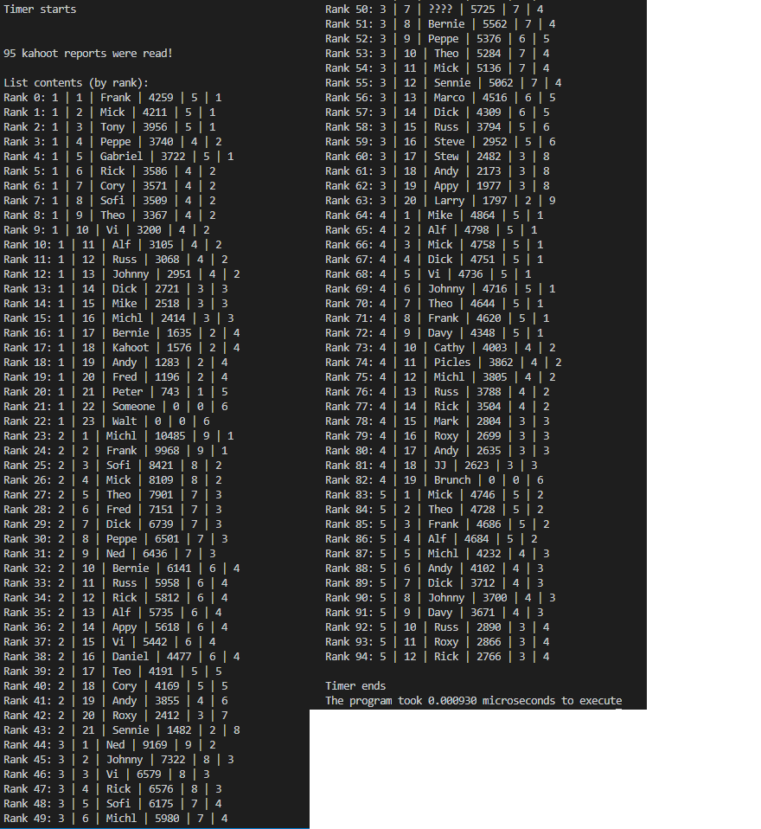

Figura - List Array List

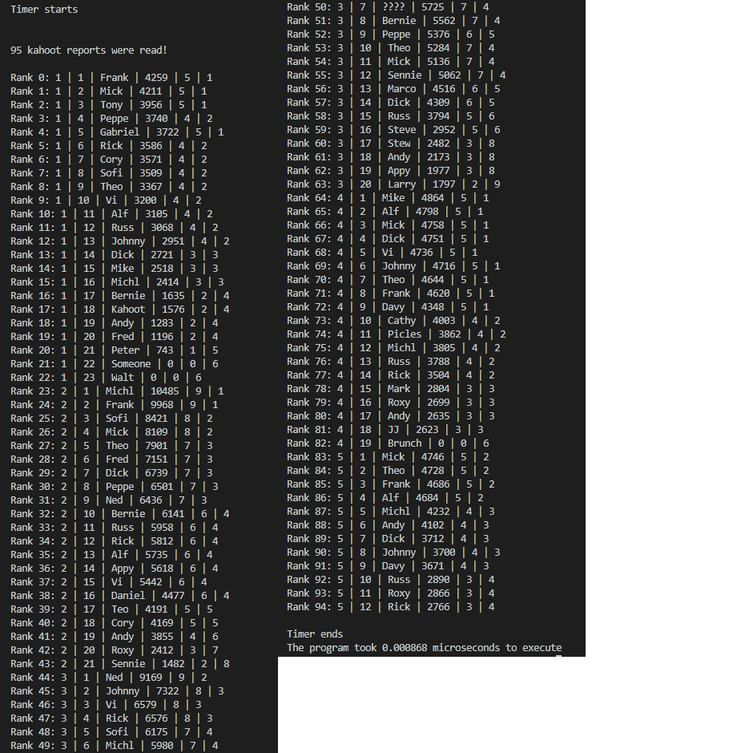

Figura 2 - List Linked List

A implementação com linked list é mais rápida (0,000062 microssegundos) que a implementação com array list.